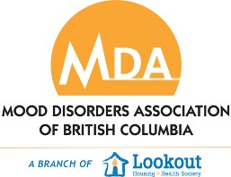
Guidelines for Participation at The Art Studios

The Art Studios is committed to providing a safe, respectful and accepting environment for people living with mental health challenges. Participants and staff work together to provide opportunities for growth and recovery through participation in art. We believe in hope and in every participant’s ability to grow and change while being supportive and respectful of one another. Here are the guidelines for:

Yourself:
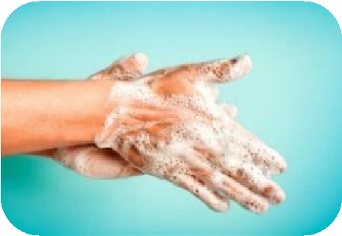
Regular hand washing & Sanitizing – No perfume or cologne. We are a scent free environment. | Arrive/leave on time unless arranged before. Attend at least 80% of classes per term. | Please do not come to the studio under the influence of drugs or alcohol. | No disruptive or distracting side conversations during class. Please no cell phone calls in studio.

Others:
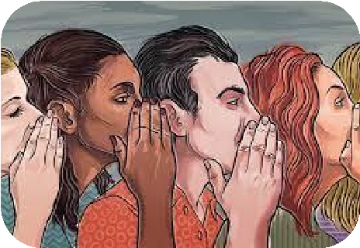
Gossiping – about others or the studio. Includes derogatory remarks, spreading sensitive information or hurtful judgements. | Respect each other’s privacy, boundaries and physical space. | Please refrain from asking others for money, food or cigarettes.

Our Studio:
 | 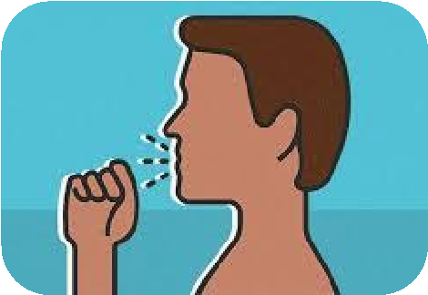
Clean your workspace. Sanitize & put away any supplies or tools used. | Please do not come to the studio while unwell or with Covid like symptoms. | Refrain from disrespectful communication – sarcasm, profanity, raising voice, name calling, blaming, shaming etc… | Refrain from harassment, assault or discrimination of any kind – physical, verbal, sexual, racial, gender etc…

